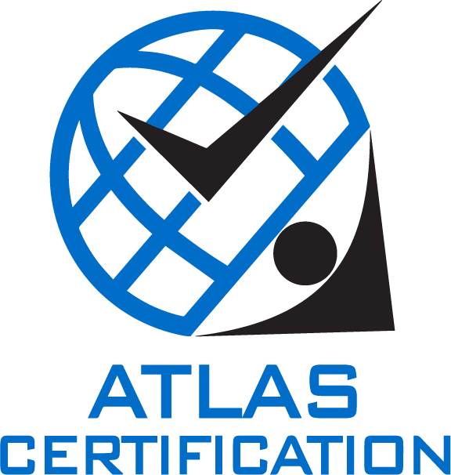

**Stage 1 - Checklist**

 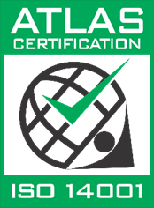 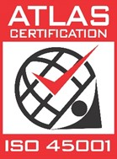

**Company name: xxx**

**Completion Date:** xx-xx-2025

| **Element** | Please select |
| --- | --- |
| **4.3 Scope of the Management System** | |
| Have you determined the Scope of your Management System and retained this as Documented Information? | select |
| Please upload a copy to folder 1. In “Shared Folder” | |
| **5.2 Policy** | |
| 5.2 Have you established a Quality Policy? | select |
| * Is this Policy retained as Documented Information? | select |
| Please upload a copy to folder 2. In “Shared Folder” | |
| * Does the Quality Policy provide a framework for setting objectives? | select |
| * Does the Quality Policy include a commitment to satisfy applicable requirements? | select |
| * Does the Quality Policy include a commitment to continual improvement of the QMS? | select |
| 5.2 Have you established an Environmental Policy? | select |
| * Is this Policy retained as Documented Information? | select |
| Please upload a copy to folder 2. In “Shared Folder” | |
| * Does the Environmental Policy provide a framework for setting objectives? | select |
| * Does the Environmental Policy include a commitment to the protection of the environment, incl. prevention of pollution? | select |
| * Does the Environmental Policy include a commitment to fulfil relevant compliance obligations? | select |
| * Does the Environmental Policy include a commitment to continual improvement of the EMS to enhance environmental performance? | select |
| 5.2 Have you established a Safety (OHS/WHS) Policy? | select |
| * Is this Policy retained as Documented Information? | select |
| Please upload a copy to folder 2. In “Shared Folder” | |
| * Does the Safety Policy provide a framework for setting objectives? | select |
| * Does the Safety Policy include a commitment to fulfil legal and other requirements? | select |
| * Does the Safety Policy include a commitment to eliminate hazards and reduce risks? | select |
| * Does the Safety Policy include a commitment to continual improvement of the OHS Management system? | select |
| * Does the Safety Policy include a commitment to consultation and participation of workers? | select |
| **6.1.1 Risks & Opportunities** | |
| Have you identified the Risks & Opportunities that could affect the Management System’s ability to:   * achieve its intended outcomes, * prevent, or reduce, undesired effects, and * achieve continual improvement. | select |
| Have you retained Documented Information on identified Risks and Opportunities? | select |
| Please upload a copy of the relevant evidence/ records to folder (3.) In “Shared Folder” | |
| **6.1.2 Environmental Aspects** | |
| Have you determined the Environmental Aspects of your activities, products/services and assessed their associated Environmental Impacts? | select |
| Have you established and implemented criteria to determine the aspects that have or can have a significant environmental impact (i.e., significant Aspects)? | select |
| Please upload details of identified Aspects (an ‘Aspects Register’ for example) and evidence of determination of the Aspects you consider to be ‘significant’ in folder (e1.) in “Shared Folder” | |
| **6.1.2 Hazards and Risks** | |
| Have you identified the Hazards and developed and implemented processes to assess their associated Risks? | select |
| Please upload a copy of the relevant evidence in folder (s1.) in “Shared Folder” | |
| Do you have examples of SWMS, JSA’s that are used by your organisation (if applicable)? | select |
| Please upload copies of both templates and completed examples in folder (s2.) in “Shared Folder” | |
| Do you maintain a (hazardous) chemicals register (if applicable)? | select |
| Please upload a current copy of the register in folder (s3.) in “Shared Folder” | |
| **6.1.3 Compliance Obligations** | |
| Have you identified relevant Compliance Obligations (incl. Acts, Regulations, Codes of Practice, Australian Standards, etc.) for the jurisdictions in which your organisation operates? | select |
| Please upload a current copy of the register/evidence in folder (s4.) in “Shared Folder” | |
| **6.2 Objectives** | |
| Have you determined measurable Objectives, aimed at continual improvement of the Management System and/or its results? | select |
| Please upload a copy of the relevant evidence in folder (4.) in “Shared Folder” | |

| **Element** | Please select |
| --- | --- |
| **9.2 Internal Audits** | |
| Have you developed an Internal Audit programme to demonstrate it has been determined what, when and how Internal Audits will be conducted to verify:   * the Management System’s conformity with the requirements of the relevant Standards; * the effective implementation of the Management System? | select |
| Please upload a current copy of the Internal Audit programme in folder (5.) in “Shared Folder” | |
| Have Internal Audits been conducted in accordance with the Internal Audit programme?*  \**please note it is a requirement that Internal Audits have been conducted before progressing to the Stage 2 Audit can be recommended.* | select |
| Please upload a copy of a recent Internal Audit report in folder (6.) in “Shared Folder” | |
| **9.3 Management Review** | |
| Has at least one Management Review, taking into consideration the required inputs and generating the required outputs been conducted?*  \**please note it is a requirement that at least one full Management Review has been conducted before progressing to the Stage 2 Audit can be recommended.* | select |
| Please upload records of the Management Review in folder (7.) in “Shared Folder” | |
| **10.2 Non-Conformities and Corrective Actions** | |
| Have you developed processes to record and communicate identified Non-Conformities (incl. complaints, incidents, etc.)? | select |
| Have you developed and implemented a process to ensure Corrective Action is taken to prevent recurrence of similar Non-Conformities, incl.:   * evaluation of the need for Corrective Action by determining the root cause and likelihood of recurrence; * review of existing Risk Assessments; * consideration of the Hierarchy of Controls; and * review of effectiveness of the Corrective Action taken? | select |
| Please upload templates and/or examples of incident reports/ complaints and Corrective Actions taken in folder (8.) in “Shared Folder” | |
| **Other evidence** | |
| Please upload any further supporting evidence that you consider relevant (incl. Management System Manuals, relevant procedures, etc.) in folder (9.) in ‘Shared Folder” | |

### END OF DOCUMENT ###